EcoPeace Middle East Co-Directors’ Bios
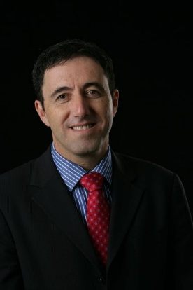
Gidon Bromberg co-founded EcoPeace Middle East in 1994 and has served as its Israeli Director for the past 23 years. In that time Mr. Bromberg helped develop the flagship education and water diplomacy programs of the organisation, recognised by TIME magazine, the Skoll Foundation and the Aristotle Onassis Foundation, to name but a few. Mr Bromberg has written extensively on the relationship between water issues and Middle East peace and has presented before the US Congress, European Parliament and UN forums. Mr. Bromberg, an attorney by profession, is an alumni of Monash University in Australia, Washington College of Law at American University and Yale University's World Fellows program.
Nada Majdalani is the Palestinian Co-Director of EcoPeace Middle East. Formerly she was a consultant, researcher and practitioner in the field of environmental management. She has occupied leading technical positions in various projects in the areas of infrastructure development, solid waste management, wastewater treatment and institutional capacity building. Mrs. Majdalani had an extensive experience in the Private Sector Development. This experience allows Mrs. Majdalani to understand the interests of planners and entrepreneurs in contributing to the economic growth, while considering sustainability aspects.
Yana Abu Taleb is the Jordanian Deputy Director of EcoPeace Middle East. She received a Bachelor Degree in Archeology from the University of Jordan in 1996. As Regional projects manager at EcoPeace Middle East, she leads EcoPeace’s projects and advocacy and her responsibilities include supervising project development, planning and management, serving as a liaison to and lobbying of governmental and private sector figures and organizations on major regional policy issues relevant to environmental protection and national and regional water issues. She has organized many regional conferences, workshops and study tours, co-authored reports and policy papers and speaks regularly at local and international conferences.

